How to get a list of all Alma vendors without linked orders | 

Yoel Kortick
Senior Librarian

Question:
How can we get a list of all Alma vendors without linked orders

Answer:
Vendors with no POLs will not be in the Funds Expenditures subject area because there is no POL or transaction for the vendor which would trigger them to be in the Funds Expenditures subject area. Thus the solution can be as follows:
ONE
In Alma do “Acquisitions > Acquisitions Infrastructure > Vendors” to get a complete list of vendors.
Export the list to Excel.
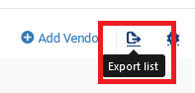

TWO
Edit the Excel file and save only the column with vendor code and remove all other columns.
Call the file “All vendor codes”.
Here is the beginning of the file:
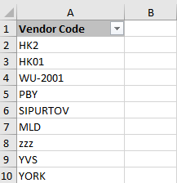

THREE
In Alma analytics make a report which includes the “Vendor Code” from the “Vendor” Folder.
Filter by “PO Line Reference” from the “PO Line” folder is not null.
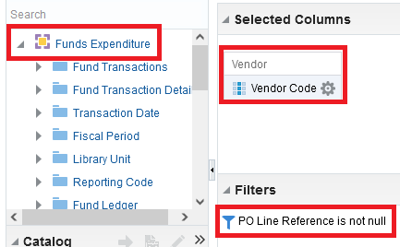

FOUR
Export the Analytics report to Excel.

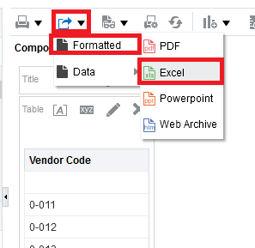

Call the file “All Vendor Codes which have an order”
FIVE
Now we need to get all vendor codes which are in file “All Vendor Codes” and are not in file ““All Vendor Codes which have an order”. You can do this with Excel tools or with online tools such as “TextCompare” at https://www.textcompare.org/excel/
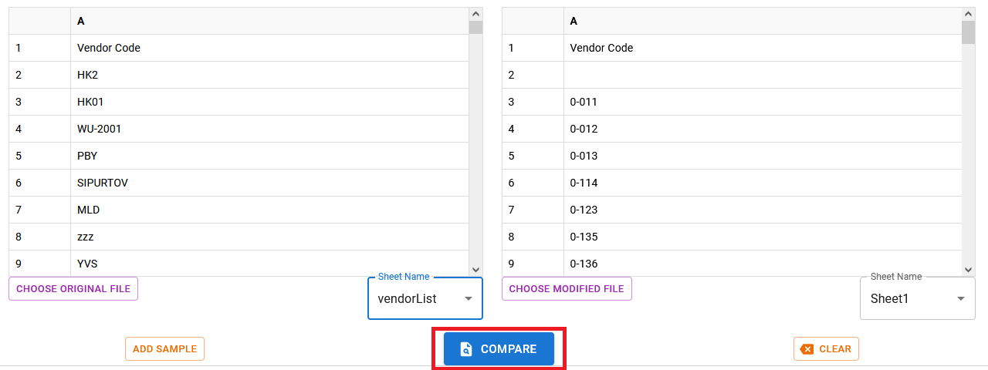

SIX
Here is part of the output. Let’s check the first two examples: vendors codes “HK2” and “HK01”

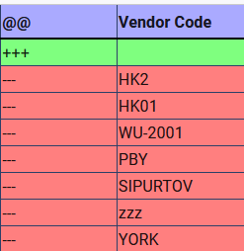

They both have no POLs

